PROJECT HEADING

A Mini project report

BACHELOR OF COMPUTER SCIENCE
(2024 – 2027)

Submitted by

POONGAVANAM P KEERTHIKA P
222408431 222408425

YAMUNA G BHUVANESHWARI R
222408444 222408407

Under the Guidance of
Mrs. V. THILAGAVATHY M.Sc., M.Phil.
Assistant Professor
Department of Computer Science



SOKA IKEDA COLLEGE OF ARTS AND SCIENCE FOR WOMEN,
MADHANANGKUPPAM, CHENNAI – 600 099.
Affiliated to the University of Madras, Chepauk, Chennai 600 005.
ABSTRACT (Backend product Spendwise)
• Spendwise is a backend application built to help beginner developers learn backend development.
• It uses technologies like Node.js, Express.js, MongoDB, and JWT authentication.
• The main goal is to teach how to build secure REST APIs used in real-world applications.
• It includes user authentication so users can register and log in securely.
• JWT (JSON Web Token) is used to protect routes and verify users.
• The application implements basic CRUD operations (Create, Read, Update, Delete).
• Developers learn how to structure backend code in a clean and simple way.
• It helps students understand how backend systems manage data and users.
• The project is designed as a practical learning example for real-world backend development.

CHAPTER | CONTENT | PAGE NO
1. | PROJECT OVERVIEW | 3
2. | PROJECT INSTRUCTION | 5
3. | PRE-REQUISITES | 6
4. | PROJECT ARHITECTURE IMAGE | 6
5. | ER DIAGRAM | 8
6. | ROLES AND RESPONSIBILITY | 9
7. | BACKEND DEVELOPMENT | 10
8. | DATABASE DEVELOPMENT | 13
9. | PROJECT EXECUTION | 14
10. | CONSLUSION | 17

Project overview
SpendWise is a comprehensive financial management application designed to track user income and expenses, set budgets, and visualize spending habits through analytics. It offers tools for data categorization, secure storage, and reporting to improve personal or business financial health.

Key Objectives
- Enable Effective Expense Tracking: Provide a user-friendly interface to easily record daily, weekly, or monthly expenses.
- Automate Budget Management: Allow users to set budgets for different categories (e.g., food, transport, rent) and receive real-time alerts when approaching or exceeding limits.
- Provide Financial Analytics: Use visual aids like charts and graphs (e.g., Chart.js) to display spending patterns and trends.
- Enhance Financial Literacy: Educate users through AI-powered tips and insights, fostering responsible spending habits.
- Ensure Data Security: Implement secure authentication (e.g., JWT) to protect sensitive financial information.
- Students: Specifically designed to help students manage limited budgets and track spending.
- Young Adults/Individuals: Aimed at young professionals or anyone looking for a simple, intuitive tool to manage personal finances.
- Budget-Conscious Consumers: People seeking to increase awareness of their spending habits without complex software.

Target Users for SpendWise:
- Beginner Backend Developers – People who are starting to learn backend development using Node.js and want a simple project to understand how APIs work.
- Computer Science Students – Students who need a practical project to learn concepts like authentication, databases, and REST APIs.
- Self-taught Programmers – Individuals learning web development online who want hands-on experience with real backend technologies.
- Bootcamp Learners – Students in coding bootcamps practicing how to build secure backend applications.
- Junior Developers – Developers who want to improve their understanding of API security, JWT authentication, and CRUD operations.
Project instruction
Spendwise is a backend only project built using Node.js and Express.
Quick start:
npm init
npm install
npm run dev
Steps to create the project
- Choose or create a directory for the backend project
- Open terminal and navigate to that directory
- Initialize Node.js project using npm init
- Install required pakages: express, mongoose, jsonwebtoken, bcypt, cors, dotenv
- Create folders: models, routes, controllers, middleware, config
- Start the server using npm run dev
- Test API using Postman or Thunder Client at http://localhost:5000

Pre-requisites
Software Requirements
Software Purpose
Node.js JavaScript runtime for backend
MongoDB NoSQL database for data storage
Npm Package manager
Git Version Control system
Code Editor VS Code or similar

Knowledge Requirements
- JavaScript basics (functions, async/await)
- Node.js fundamentals
- Express.js for building REST APIs
- MongoDB and Mongoose for database management
- CRUD operations (Create, Read, Update, Delete)
- JWT authentication for securing APIs
- Password hashing using bcrypt
- API testing using tools like Postman

PROJECT ARCHITECTURE IMAGE
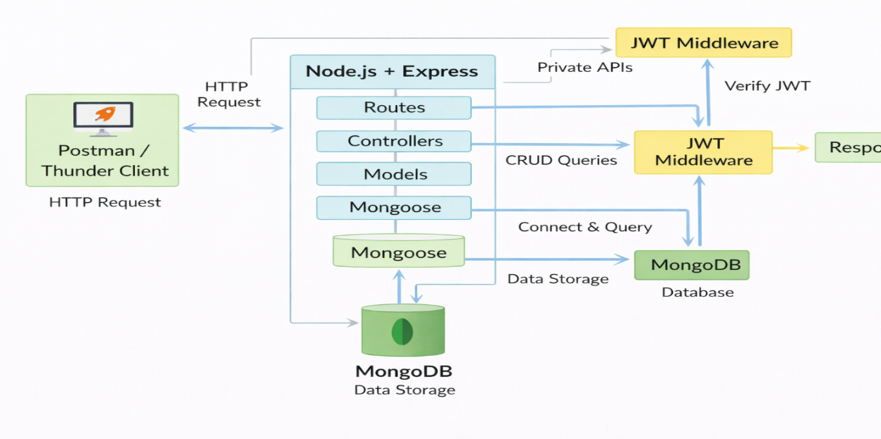

Technical Architecture
Backend Architecture (Node.js + Express)
- Controllers: Handle business logic for authentication and CRUD
- Models: Mongoose schemas for User and Transaction
- Routes: API endpoints for auth and CRUD operations
- Middleware: JWT verificationa and request protection
- Configuration: Database connection and environment variables

Database Architecture (MongoDB)
- Users Collection:
_id , name ,email ,password.,createdAt.,updatedAt
- Transation Collection:
_id,userld,type,amount, category, description, date, createdAt
- Realtionship:
• The relationship between Users and Transactions is One-to-Many (1:N).
• One user can have many transactions.
• Each transaction belongs to only one user.

ER Diagram

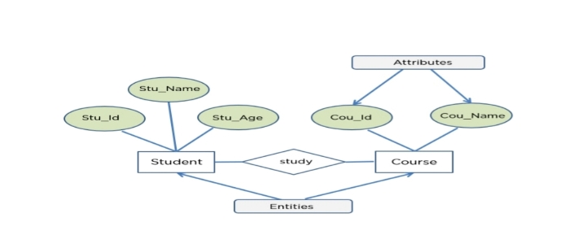

Features
Features Description
User Authentication JWT-based registration and login
CRUD Operations Create, Read, Update, Delete transactions
Protected Routes Seacure APIs using JWT middleware
MongoDB Integration Store and fetch data using Mongoose

Roles and Responsibilites
Student/Developer:
- Write backend code
- Create APIs
- Test APIs using Postman/Thunder Client
- Push code to GitHub
System (Backend)
- Authenticate users using JWT
- Handle CRUD operations
- Store and fetch data from MongoDB
- Protect private routes
Users Flow: 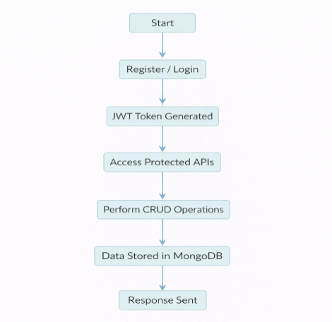

PROJECT SETUP AND CONFIGURATION
Folder structure
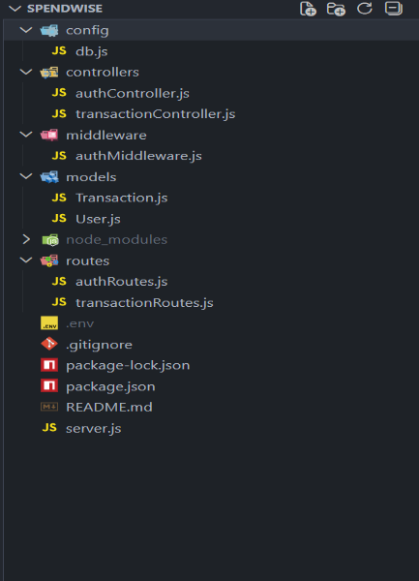
Project setup
1.install required tools:
Node.js
MongoDB
2. Create project folders:
- server folders (models, routes, controllers, middleware, config)

3. Install Backend Packages:
- Express
- Mongoose
- Cors
- Jsonwebtoken
- Bcrypt
- Dotenv

BACKEND DEVELOPMENT
- Setup Express server
- Create server.js file
- Create .env file and define PORT and URL
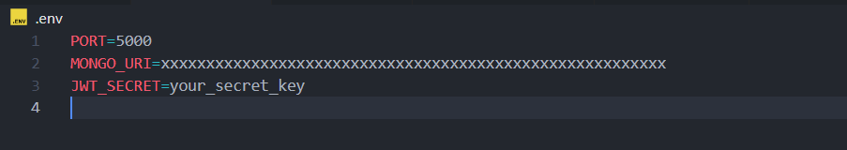

- Configure middleware (cors, express. json)
- User Authentication:
- Create Register and Login routes
- Generate JET token
- Protect routes using middleware
- Define API routes:
- Auth rotes
- 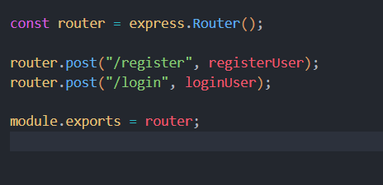
- Transaction CRUD routes

- Implement Data Models:

- User schema

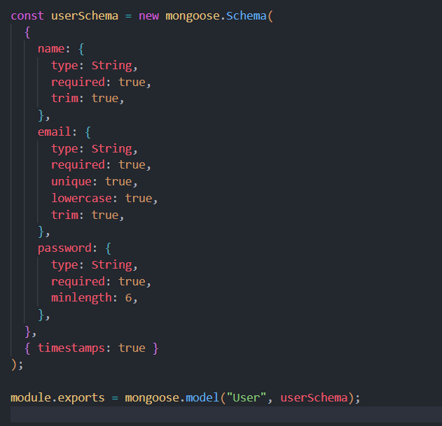
- Transaction schema
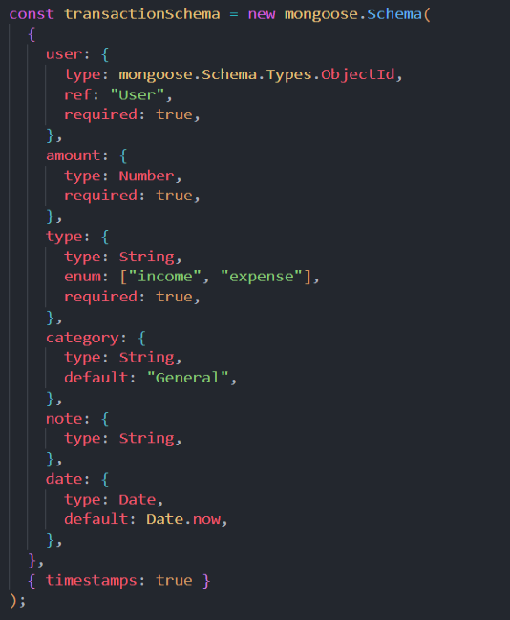

- Implement CRUD operations
- Add basic error handling

DATABASE DEVELOPMENT

Configure MongoDB
- Use MongoDB Atlas or local MongoDB
- Store connection URL in .env file
- Connect using Mongoose

Create Database Connection
- Create a config file for DB connection

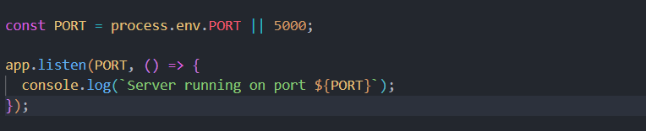
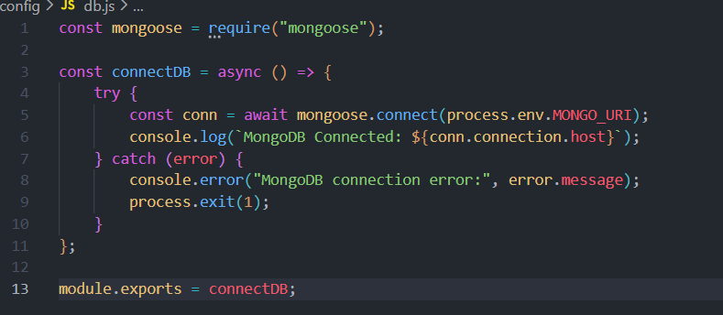
- Use mongoose.connect()
- Handle success and error cases

Create Schema and Models

User Model:
- Name
- email
- password

Data / Transaction Model:
- userId
- title / description
- amount / value
- timestamps

PROJECT EXECUTION

Project Execution Steps:
- Start MongoDB
- Run backend server
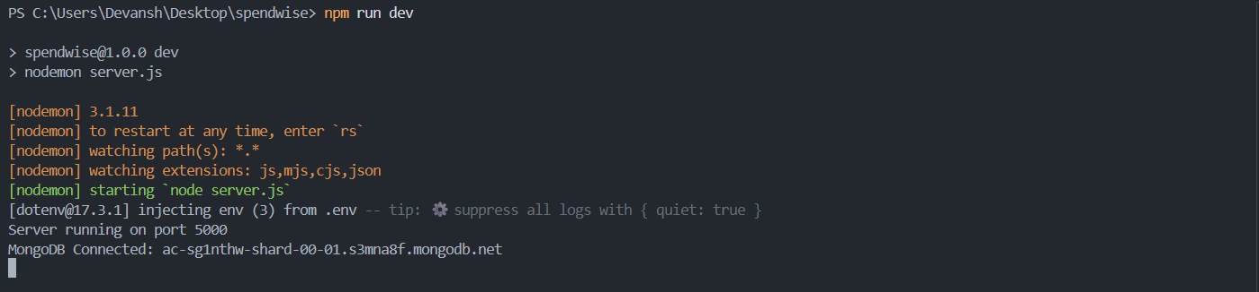

3.Test Register API
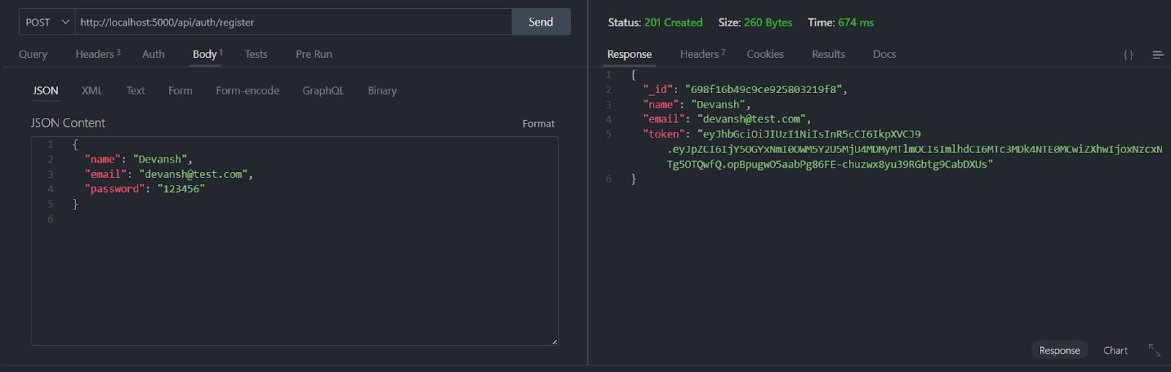
4.Test Login API
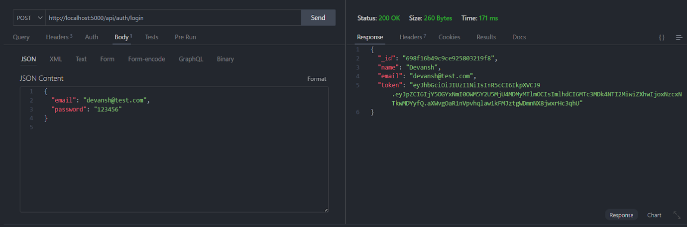

5.Copy JWT token
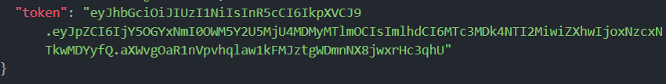

6. Use token to access protected CRUD APIs
7.Perform Create, Read, Update, Delete operations

OUTPUT SCREENSHOT

1.Register API
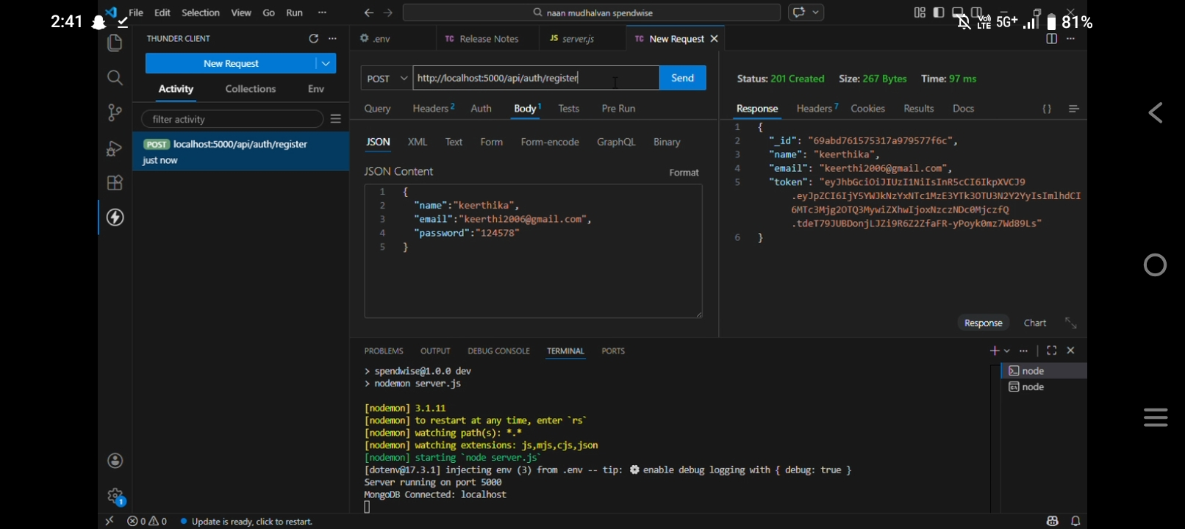

2.Login API
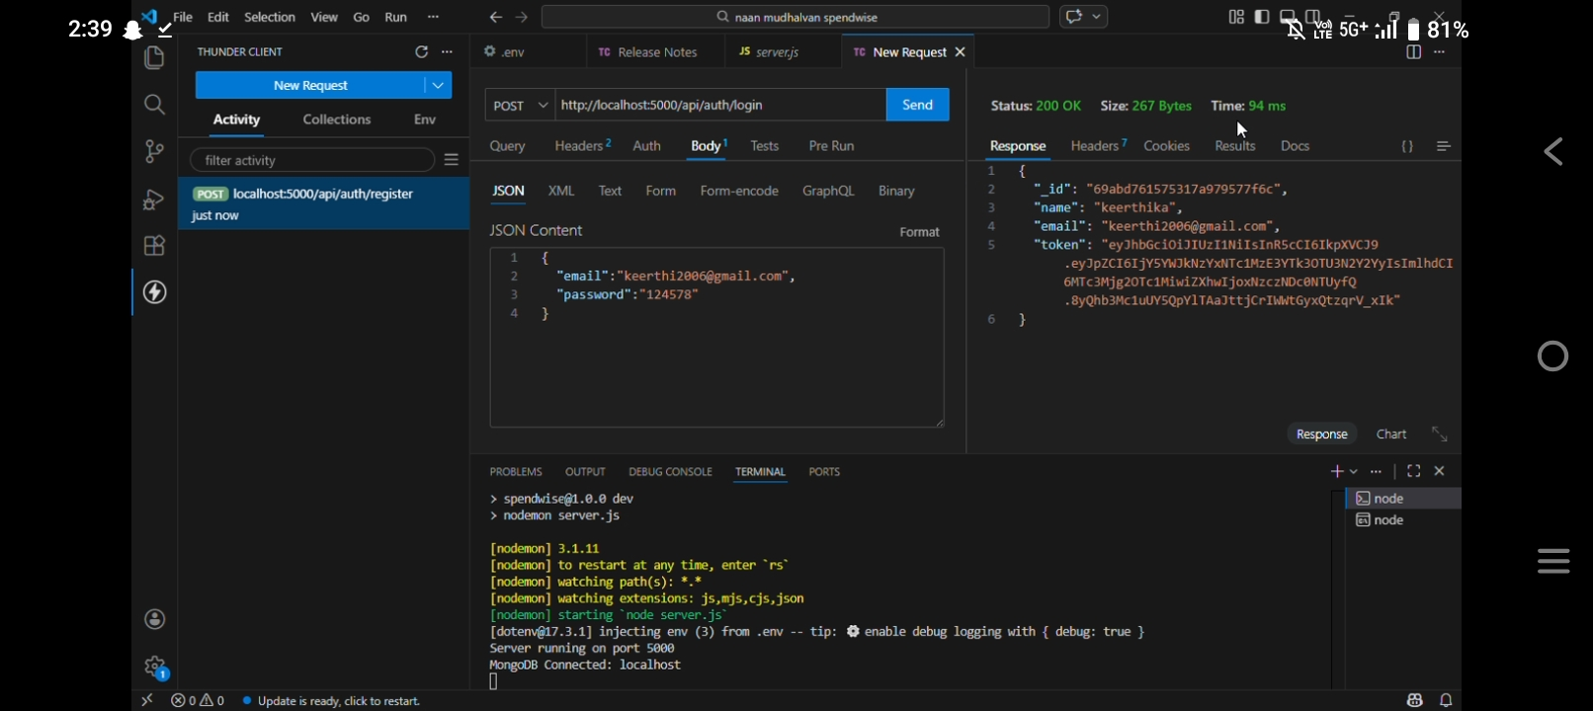

3.Create Transaction
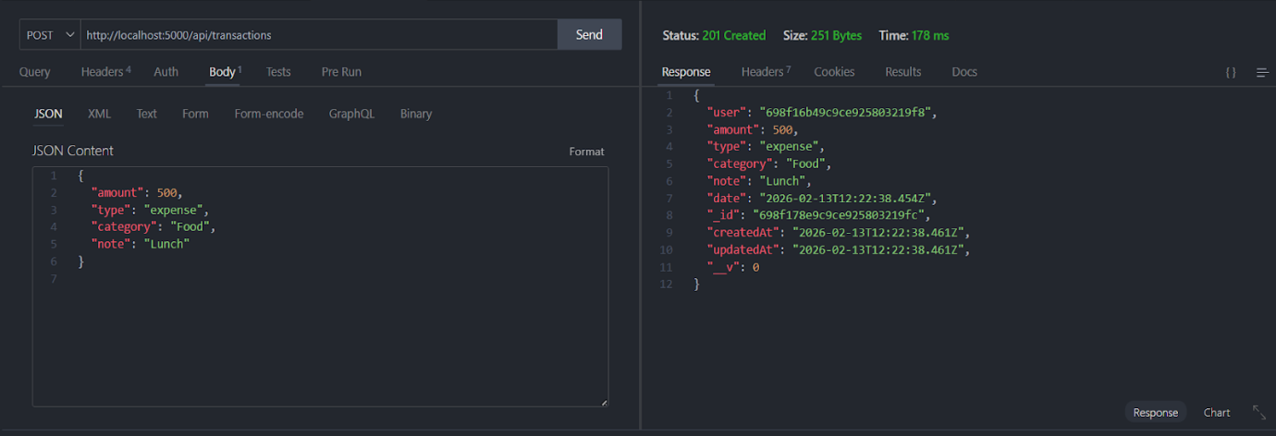
4.Get information
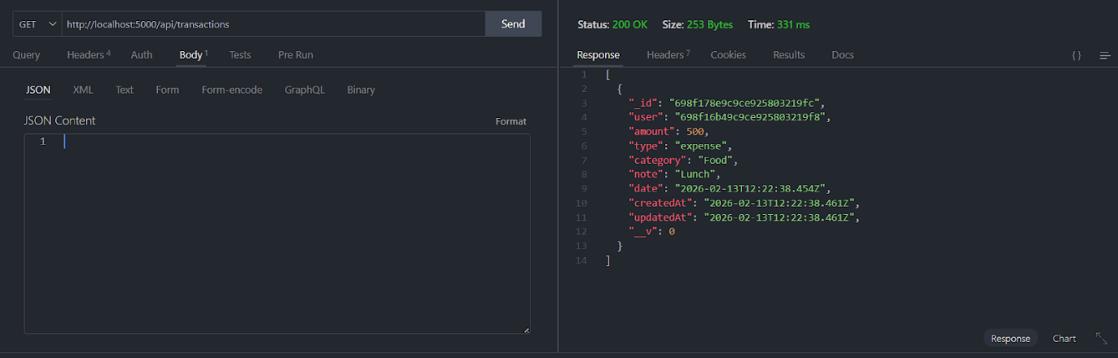

5. Update API
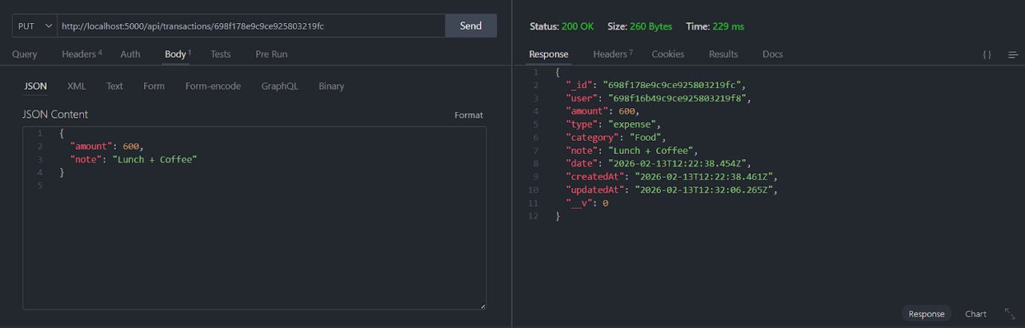

6.Delete 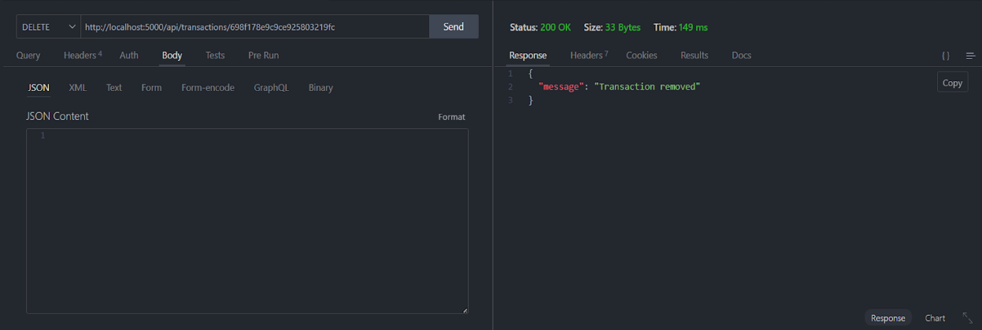

CONCLUSION
The SpendWise backend provides a secure and efficient system for managing user authentication and expense data. It ensures reliable data storage, smooth API communication, and supports the core functionality of the application. The structured design also allows easy scalability and future feature enhancements.

